TRIGGER EXPERIMENT
Creating the table
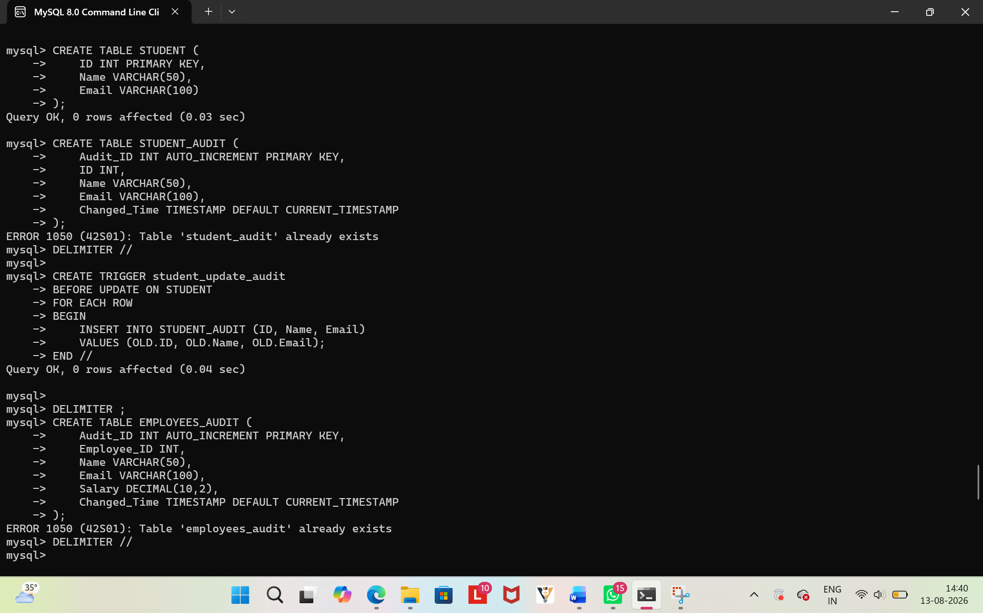
Trigger query
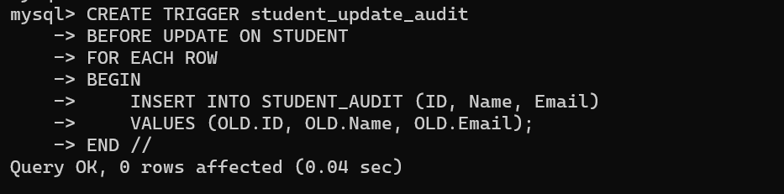

OUTPUT FOR TRIGGER
